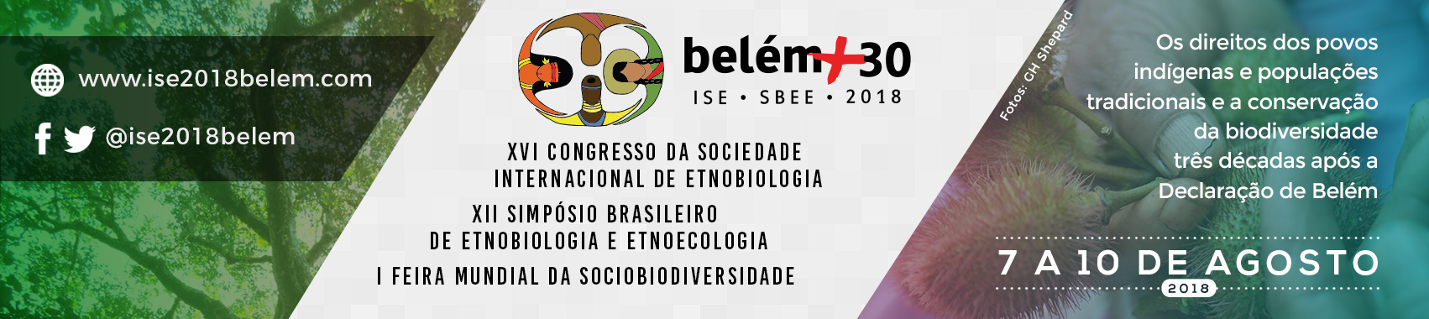
Ethnobiology in the 21st Century: reflecting on the Declaration of Belém 30 years on”

The International Society of Ethnobiology’s (ISE) 5th Pre-Congress Workshop for Emerging Ethnobiologists
2nd-6th August 2018
Sirituba, Brazil

Call for Applicants
Information required from applicants
As space is limited to 20 participants, an application/selection process will be used for participation in this workshop. Applications will be accepted from those in the early stages of their career in all fields related to ethnobiology. Applications should be submitted to the ISE Student Representatives Jennie Harvey (jennie.harvey@canterbury.ac.uk) and Michel Rapinski (micheal.rapinski@umontreal.ca) by 11th June. Queries can also be directed to one of the student representatives.
Applicants are asked to submit an abbreviated Curriculum Vitae (limit: one page) and a statement of no more than 1000 words which outlines:
- Contact information (Name, Affiliation, Mailing address, Email address)
- Stage in career
- Motivation for attending the workshop. In your motivation statement, please answer the following questions:
  - What is/are your learning objective(s) from this workshop, i.e. what do you expect to learn from the workshop?
  - How will this workshop contribute to your personal and professional goals?
  - What skills and knowledge will you bring to the workshop?
- Statement of fluency in English (if not your mother tongue)
- Please indicate if you have been accepted to present your work at the ISE Congress. If yes, please let us know if you will be giving a poster, presentation, other?
- Please indicate if you are interested in sharing a poster/giving a short presentation on your research during the workshop.

Criteria for selecting participants
- We will only choose applicants who are current ISE members.
- We will evaluate the strength of the motivation statements and abridged CVs and select participants based on compatibility with the learning objectives of this workshop.
- We will select participants to ensure an equitable representation of gender, ethnicity, different geographic regions and participants with different ethnobiological expertise.
- We will select participants based on their ability to communicate reasonably well in English, to ensure that learners can benefit from and contribute to the activities in the workshop.

Successful applicants and payment
Successful applicants will receive an invitation to attend the workshop by June 15th and will be asked to confirm attendance and pay by June 30th to secure their place.
Once notified, a link to a payment form will be provided to applicants. Applicants will be required to pay the $250 USD by credit card or debit card.

For more information on the ISE and the upcoming congress see:
ISE Website- http://www.ethnobiology.net/
Congress Website- https://www.ise2018belem.com

